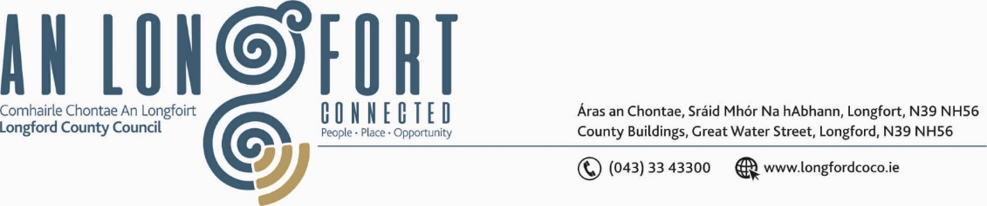

***BALLYMAHON MUNICIPAL DISTRICT***

***Please note meeting will be held in Ballymahon Library.***

**21 July 2023.**

**To: Each Member of Ballymahon Municipal District.**

**Dear Member,**

You are requested to attend a Meeting of Ballymahon Municipal District to be held

**in Ballymahon Library** on **Thursday 27 July 2023 at 4pm** to transact business, as set out on the agenda hereunder.

**Yours sincerely**,

_______________

**Claire McNabola,**

**Meetings Administrator.**

**AGENDA**

Prayer before meeting.

1. Confirmation of Minutes
2. Ballymahon Municipal District Committee Meeting held on the 25 May 2023 – enclosed.
3. Ballymahon Municipal District Meeting held on the 25 May 2023 – enclosed.
4. Ballymahon Municipal District Annual Meeting held on 22 June 2023 - enclosed.

**2.** Matters arising from Minutes

**3.** Declaration of Interest by Members

**4**. Management Report

**5**. Consideration of request from Ballymahon Landevant Town Twinning Committee to hold an Official Welcome for Landevant visitors on August 8th

**6.** Notices of Motions, submitted by Councillors, as listed hereunder –

**Councillor Mick Cahill**

1. I call on Longford County Council reduce the speed limit on the R398-712 at Cloontagh NS in the interests of Road safety.
2. That Longford County Council consider appropriate measures to reduce Traffic Congestion at School times at Cloontagh school.

**Councillor Pat O’Toole**

I call on Longford County Council and the Inland Fisheries Board to provide a slipway for small boats, kayaks, and canoes adjacent to the 8-berth jetty at the Red Bridge Ballymahon.

**Councillor Paul Ross**

1. I call on Longford County Council to seek funding to resurface the Main Street of Edgeworthstown as a matter of urgency.

1. I call on Longford County Council to extend the footpath on the Ratharney side of Legan to Kelly’s crossroads in the interest of public safety

**7**. Correspondence

**(i)** Correspondence received on 18 May 2023 from Department of Housing, Local Government and Heritage re. Energy Retrofit Programme